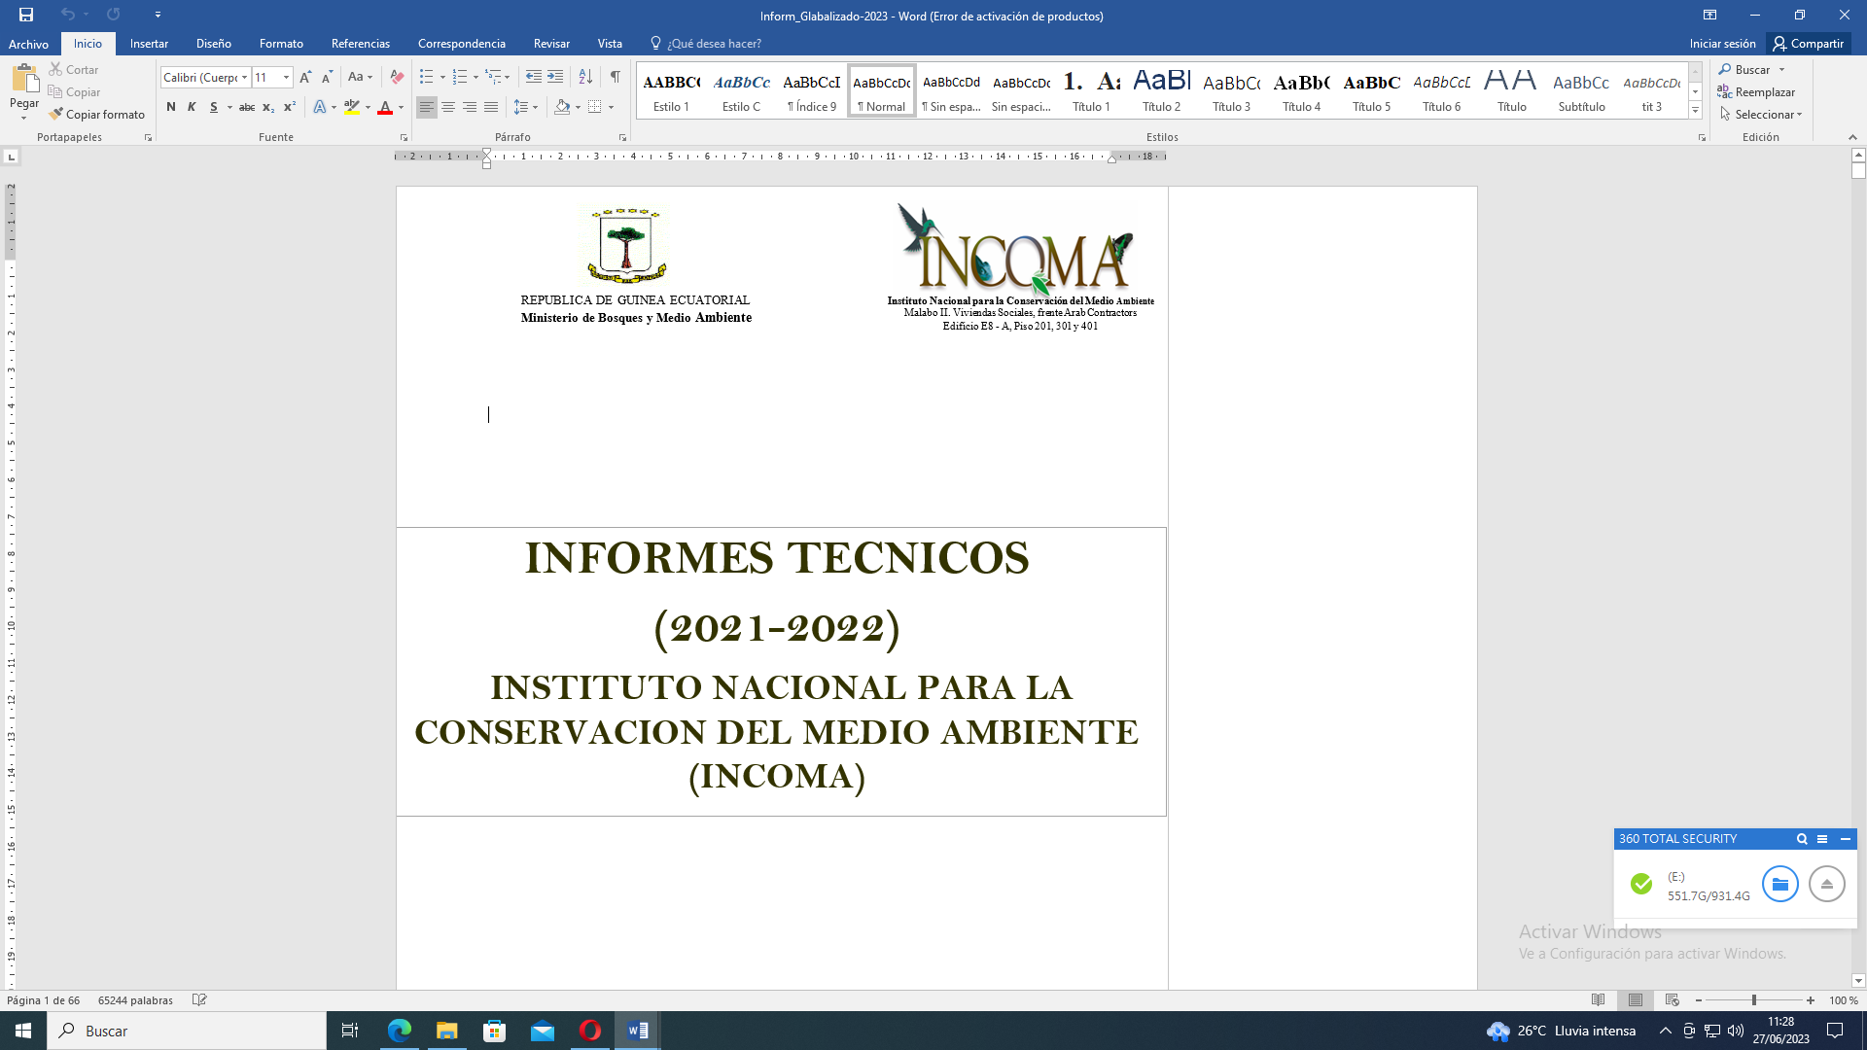  REPUBLICA DE GUINEA ECUATORIAL  Ministerio de Agricultura, Ganadería, Bosques, Pesca y Medio Ambiente |  | 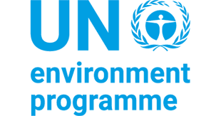 | 

JOB DESCRIPTION

Position title: Finance and Administration Expert

Reports to: The National Project Director
Technical / Dotted Reporting Manager(s): Chief Technical Advisor and UNEP GEF Agency
Supervises: Under the National Director the following - Support Staff; Field execution partners.
Location: Malabo
Project title: “Developing biodiversity, biocarbon finance and financing instruments for conserving forests in Equatorial Guinea through improved livelihoods for indigenous peoples and local communities”.
Project objective: This project aims to o strengthen biodiversity conservation and climate change mitigation, through the application of economic instruments for carbon sequestration, biodiversity protection services to support sustainable forest and land management and improved livelihoods of indigenous peoples and local communities in targeted forest landscapes in Equatorial Guinea.
Project executing organization: The Ministry of Agriculture, Livestock, Forests, Fisheries, and Environment, acting through its National Institute for Environmental Conservation (El Instituto Nacional para la Conservación del Medio Ambiente) - (INCOMA).
GEF PROJECT ID N°: 11247
Duration of project: 60 months
Duration of project: 72 months
Geographical location: Equatorial Guinea.

- Mission of the project:

The project ‘Developing biodiversity, biocarbon finance and financing instruments for conserving forests in Equatorial Guinea through improved livelihoods for indigenous peoples and local communities’ to be implemented by INCOMA, is part of the Congo IP, along with six other country-based projects and one Regional Coordination Project. The IP is aimed at improving the conservation and effective governance of critical landscapes in the Congo Basin Tropical Rainforest Biome. The Congo IP is in turn part of a broader GEF8 initiative titled “The Amazon, Congo, and Critical Forest Biomes Integrated Program”, aimed at conserving intact rainforests across the globe.

The GEF 8 project on Biocarbon tackles biodiversity loss and ecosystem degradation in Equatorial Guinea's forests, trends that will result in economic loss especially to forest-dependent and impoverished indigenous peoples and local communities, women included. The project will promote policy reforms, capacity building, and community engagement, with a strong focus on gender equality and women’s empowerment in forest conservation efforts. The objective of the project is to strengthen biodiversity conservation and climate change mitigation, through the application of economic instruments for carbon sequestration, biodiversity protection services to support sustainable forest and land management and improved livelihoods of indigenous peoples and local communities in targeted forest landscapes in Equatorial Guinea. This objective will be achieved through the following Components: 1) Enabling environment for the application of economic instruments; 2) Enhanced methodologies and gender-transformative capacity building; 3) Application of natural capital valuation, economic instruments to incentivize indigenous peoples and local communities, plus other stakeholders; and 4) KM, M&E, awareness raising and training.
The project will benefit 10,000 people, with a focus on gender equality, reaching 55% women overall and 58% within indigenous and local communities. It will manage 337,238 hectares of forest landscapes, including protected areas, forest corridors, and restoration zones, aiming to sequester 25.1 million tons of CO2 over 20 years. The project will implement sustainable land management practices using LUP and the LDN framework. It will contribute and collaborate with broader regional and global forest conservation initiatives, including the GEF’s Critical Forests Biomes program and the GEF8 Congo IP.

- Major Functions:

The Finance and Administrative expert will be in charge of daily financial management of the project. He/she shall also provide support on the procurement procedures.
The Finance and Administrative expert will be recruited jointly by both the Executing Agency (INCOMA) and the UNEP.
The Administrative and Finance Assistant will be responsible for effective management of financial and administrative aspects of program assets and financial resources; providing support in preparing quarterly and annual financial reports.
The Financial Officer provides project administration and financial support to the Project Management Unit. Specific tasks would include:
Ensure effective and high-quality support on programme administrative and financial management
- Contribute to day-to-day support for the programme implementation and ensure conformity to expected results, outputs, objectives, and work-plans;
- Ensure effective local purchases in line with applicable international standard procurement procedures;
- Maintain programme accounts;
- Provide necessary financial information as and when required for project management decisions;
- Review annual budgets and project expenditure reports, and notify the Project Director / Coordinator if there are any discrepancies or issues;
- Keep records of project funds and expenditures, and ensure all project-related financial documentation are well maintained and readily available when required by the Project Director;
- Review project expenditures and ensure that project funds are used in compliance with the Project Document and Government financial rules and procedures;
- Validate and certify applicable forms before submission to the executing agency;
- Establish and maintain the electronic and physical filing system for programme documentation and communication;
- Consolidate financial progress reports submitted by the responsible parties for implementation of project activities;
- Prepare and update proper programme documentation/records and ensure that the documents are prepared and ready for audit;
- Provide support in preparing quarterly and annual financial reports.
- Ensure effective management of financial and administrative aspects of programme assets and financial resources to meet satisfactory outcomes of the annual audit of the project; and
- Liaise and follow up with the responsible parties for implementation of project activities in matters related to project funds and financial progress reports.
Effective support to programme implementation
- Prepare budget for workshops and meetings;
- Arrange for travel for programme staff and meeting participants;
- Facilitate the organization of workshops and training programmes;
- Make arrangements and prepare the necessary documentation for all payments for activities under the programme;
- Prepare the requisite accountabilities for the programme funds (prepare cash advance statements and quarterly expenditure accounts);
- Prepare work plans and budgets for all programme activities;
- Compile the financial documentation to be submitted regularly;
- Ensure proper records and filing of the programme;
- Liaise very closely with the executing agency’s desk manager / associates to ensure the effectiveness of administrative and financial management in accordance with applicable international standard rules and regulations; and
- Maintain the registers for inventory of non-expendable equipment and ensure that the equipment is safe and in proper working conditions.
Others: Execute any other activities in relation to his/her function as requested by Project Director or through UNEP.

- Qualifications and Skills
- At least 5 years of professional experience. Relevant degree in administration, accounting, finance or related field. Knowledgeable on environmental topics. Meticulous, organized, systematic but results-oriented and with a strong ability to structure information and data
- Solid experience of budgeting, planning, and reporting on a donor-funded project. Ideally some exposure to GEF and/or UNEP;
- Knowledge in administrative and accounting procedures of the Government;
- Good computer skills in common word processing (MS Word), UMOJA, spreadsheet (MS Excel), and accounting software;
- Fluent in Spanish and English (preferably other languages as well, such French),

- Values & Behaviors:
  - Aligns and identifies with the core values of the Government of Equatorial Guinea and the UNEP Agency: Integrity, Assiduity, Respect and high sense of Collaboration.
  - Demonstrating behaviors: listen deeply, collaborate openly and innovate without limits.
  - Acts with highest integrity, accountability, and transparency.
This job description covers the main tasks and conveys the spirit of the sort of tasks that are anticipated proactively from staff. Other tasks may be assigned as necessary according to project needs.

Interested candidates should submit their application, including a cover letter and CV, to the following email addresses:
(i) Antonio Micha, GEF Operational Focal Point and Project Director
Email: ammicha025@gmail.com
Incoma155@gmail.com
(ii) With a copy to:
André Toham, UNEP/GEF Task Manager
Email: andre.toham@un.org

Only shortlisted candidates will be contacted for an interview.
Date: Approved by:

