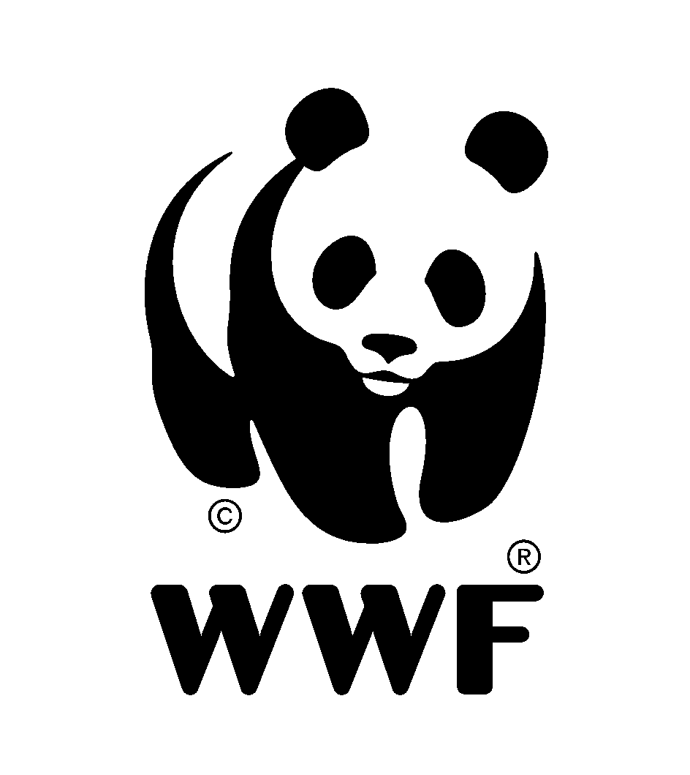

JOB DESCRIPTION

|  |  |
| --- | --- |
| Position title: | **Country Director, CAR** |
| Reports to: | Regional Director, Congo Basin |
| Supervises: | CAR Country Leadership Team |
| Grade: | Country Head, IPE PC 57 |
| Date: | June 2025 |

# 1 MISSION OF THE DEPARTMENT

|  |
| --- |
| Shape the conservation and sustainability agenda of the CAR Country Office to deliver on WWF’s global priorities nationally, regionally, and globally; and contribute to strong leadership within the WWF Network. |

# 2 MAJOR FUNCTIONS

|  |
| --- |
| To develop and lead a high performing Country Office with efficient operating systems professional and skilled staff, and strong financial resources, delivering conservation impact in places that are key for WWF’s Network Initiatives and other global conservation priorities, positioning it as the leading Conservation INGO nationally, regionally, and globally. |

# 3 MAJOR DUTIES AND RESPONSIBILITIES

|  |
| --- |
| * Lead the vision, strategic planning, and future institutional development of WWF CAR Country Office; * Accountable for the management of the WWF CAR Country Office and ensure is managed effectively and efficiently in all key programme areas: Conservation Programme, Finance & Administration, People & Culture, Partnership Development, Communications, Fundraising, Monitoring & Evaluation, and Quality Assurance; * Provide thought leadership on key issues at national level and manage key partnerships including national government, private sector and civil society, to ensure optimal communication and mutually beneficial relationships are established and maintained; * Promote the vision and objectives of the WWF CAR Strategic Plan to external and WWF Stakeholders, and participation in strategic partnership building/fundraising approaches with them as appropriate; * Develop and take leadership of the process to become a strong network office through Network support; * Provide effective leadership and guide line management to relevant transboundary or multi-country programmes; * Provide effective leadership and line management for all members of the Country Leadership Team; * Represent WWF CAR at network meetings with government, industry leaders, key supporters and stakeholders. |

# 4 PROFILE

Required Qualifications.

|  |
| --- |
| * At least 10 years professional experience in a leadership role, 3-5 years of which should be in Central African Republic with demonstrated success in managing multi-disciplinary teams. Experience with Conservation INGOs will be a strong advantage; * Master’s degree in business management, International Relations, Development, or other related fields. A degree in an environmental or conservation field will be an advantage; * Proven track record in successfully developing, leading and managing large scale programmes and/or institutions in the fields of conservation, natural resource management, international development and/or other related fields; * Superior oral and written communication skills in English and French. Fluency in Sango is an added advantage. |

Required Skills and Competencies.

|  |
| --- |
| * Demonstrable and strong leadership in external engagement, strategic partnerships, policy and influencing with public, private sector and with funding agencies; * Entrepreneurial leadership skill with demonstrable success in mobilizing funding and technical resources for national and sub-regional conservation programmes; * Empowering leadership style in developing strong senior management and operations teams to enhance programme delivery, quality assurance, operational efficiency and risk management; * A track record of building organizational talent by nurturing a performance culture and encouraging empowerment and delegation; * Strong interpersonal and communication skills that support the ability to represent the organization at a range of local and international fora, media and general public; * High-level negotiation, collaborating and influencing skills and the capacity to develop and maintain strong relationships at all levels in the business, not-for-profit, scientific and political communities; * Embraces the WWF mission and values of the organization: Courage, Integrity, Respect & Collaboration. |

# 5 WORKING RELATIONSHIPS

Internal.

|  |
| --- |
| Works closely with the WWF CAR Country Leadership Team, coordinates with the Regional Office Management Team, the WWF Network. |

External.

|  |
| --- |
| Interacts with the leadership of national government institutions, (I)NGOs, Academic Institutions, Media, Donors, Specialists/Consultants and other stakeholders in collaboration with the Regional Director as appropriate. |

This job description covers the main tasks and conveys the spirit of the sort of tasks that are anticipated proactively from staff. Other tasks may be assigned as necessary according to organisational needs.