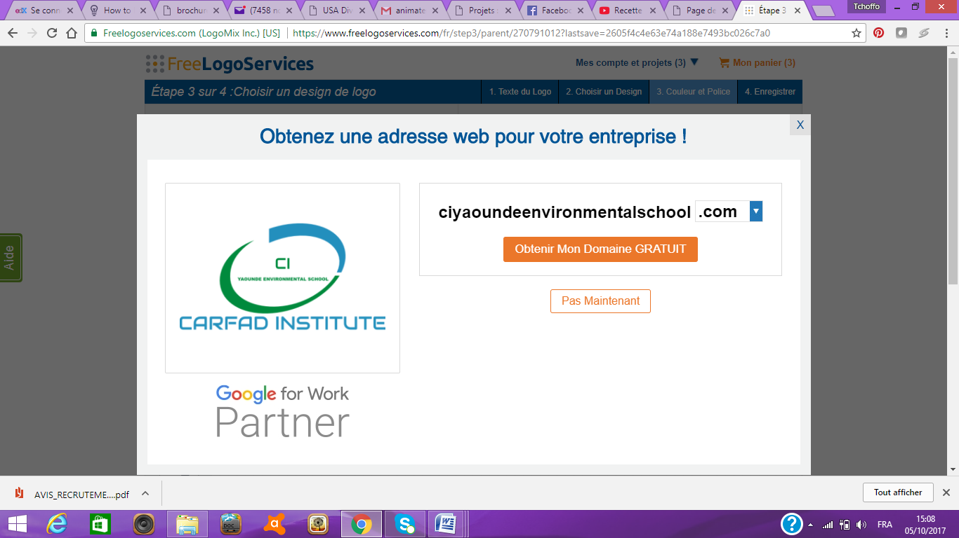
Centre of Excellence for Training in Environmental and Social Management of the African Centre for Applied Forestry Research and Development (CARFAD)

CARFAD INSTITUTE
Approved by the STATE by Order No. 022 / MINEFOP / SG / DFOP / SDGSF / SACD of January 04, 2016
REGISTRATION FORM
(To be filled by the candidate)

- PERSONAL INFORMATIONS
Names (upper case letters): .……........................................................................................................

Surnames: ............................................................................................................................................

Gender: ………………………………………………………………………………………………………….

Nationality : ……………………………...................................................................................................

Date and place of birth: ………………………………………………………………………………………..

Email: .…………………………………………………………………………………………………………...

Telephone: ………………………………………………WhatsApp…………………………….................

Facebook: …………………….............................................................................................................

Address: ……………………………………………………………………………………………………......

Town: ……………………………………………………………………………………………………………

Country: …………………………………………………………………………………………………………

Current occupation: …………………………………………………………………………........................

Organisation / Employer: ……………………………………………………………..................................

Position occupied: ……………………………………………………………………................................

Number of years of working experience: ……………………………………………………………………

Name and address of persons to contact in case of an emergency: ...................................................
…………………………………………………………………………………………………………………….

- ACADEMIC TRAINING

Certificate | Date of achievement  (Start date - End date) | Place/Venue

- TRAINING TO FOLLOW

What type of training do you want to follow?
a- Long term (specify which one): ......................................................................................................
□ ENVIRONMENTAL AND SOCIAL MANAGEMENT
□ SOCIAL MANAGEMENT, GENDER AND GENDER BASED VIOLENCE (GBV)

b- Short term (specify which one): ……………………………………………………………………………

What do you expect from this training? .…………………………………………………………………….
………………………………………………………………………………………………………………………………………………………………………………………………………………………………………….
…………………………………………………………………………………………………………………….
…………………………………………………………………………………………………………………….
…………………………………………………………………………………………………………………….

How did you hear about CARFAD INSTITUTE? :
Through a friend ………Through the internet …….... Through the press.……...
Other (s) to be specified) ....…………………………………………………………........................

- COMMITMENT OF SUPPORT

Organisation / Parent /Others: …………………………………………………………….........................
Address: ………………………………………………………………………………………………………..
Fax : ………………………Tel. ……………………E-mail : ……………………………………………….
Method of payment (specify): Bank transfer………… Cheque ……… Cash …………

Name, date and signature of officer (organization, parent, others) if applicable: | Name, date and signature of candidate :

CONSTITUTION OF APPLICATION FILE
- Registration form;
- Cover letter;
- Curriculum Vitae (CV);
- Copy of the last certificate;
- Copy of birth certificate ;
- Copy of National Identity Card (NIC) ;
- Receipt of payment of the fees of 20,000 FCFA for study of the file (to be paid directly to the headquarters of CARFAD INSTITUTE or by bank transfer to the following account 10005 00010 00472631001 94 in the name of CARFAD at Afriland First Bank)
- Prove of financial capacity to pay the training costs

